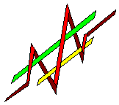

Risk Monitor for SAPHIRE

Mini Manual –

Index

- Introduction
1.1 First Program Execution
- Workspace Overview
- Initial Mapping
  - Mapping of Basic Events to Base Components
  - Creation of Component Hierarchy
- Operational Task Management
  - Main Tool Bar
  - Task Tree
    - Add Group
    - Add Task
    - Add Mode
    - Remove
    - Time
    - Component List
  - Task Graph
  - Out of Service List
  - Out Of Service Graph
  - Modes and Risk Levels
- Review and Oversight

- Introduction
The Risk Monitor for SAPHIRE software program was developed to provide a graphical interface to the complex risk analyses system used by the SAPHIRE risk assessment tool. The Software consists of two main views. The first, which is active upon entering the program, is known as the Operational Task Management (OTM) view. This first view provides the user with the ability to graphically schedule and unschedule tasks. Tasks are the representation, used by the program, of groups of components that are out of service. After initial setup by an administrative user Risk Monitor associates basic events from SAPHIRE with components. Components are linked to procedures and groups of procedures make up tasks.

The second view the Risk Monitor provides is the Review and Oversight (RO) view. In this view the user can analyze what effects the implementation of tasks has on the risk level of the modeled system. Data can be analyzed through several methods and a list of critical components can be obtained as well as a diagram of the system or component in question.

This document contains a brief introduction to the user interface of the Risk Monitor program.

  - First Program Execution

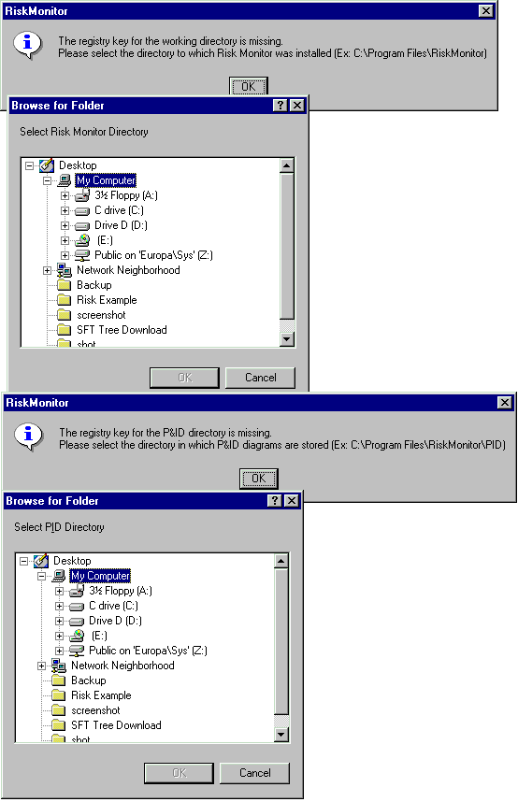
The first time the program is executed the registry keys that store the working directory and piping and instrumentation directories will be blank. These directories must then be selected through the Browse for Folder dialog. The working directory should be the directory that Risk Monitor was installed to, which has RiskMonitor.exe in it. The piping and instrumentation directory is the directory where the program will look for all piping and instrumentation files or component diagrams.

- Workspace Overview
The top-level organizational aspect of the Risk Monitor program is the workspace. A workspace acts as a container or scenario much like a document published through a word processing program. A user can have many workspaces open at one time. This is represented by the tab strip, labeled with the workspace names, that contains both the OTM and RO views. Any action (button click, time change, etc) happens to the active workspace, or workspace listed on the top tab. Actions that are illegal for that workspace will be grayed out or unavailable. It is possible to open an existing workspace, or to create a workspace by clicking on buttons on the Main Tool Bar or selecting the appropriate option from the File menu. To close a workspace make sure the workspace is active and then select the close option from the File menu.

- Initial Mapping
  - Mapping of Basic Events to Base Components
Before the Risk Monitor is operable a connection must be made between the Risk Monitor program and the SAPHIRE program. SAPHIRE is a sophisticated tool for risk analysis. In brief, a SAPHIRE model is the basis for risk calculation. All SAPHIRE models use basic events as triggers for fault trees. Basic Events are the lowest level of hardware, software, or human interactions. These basic events are created by risk analysts and are not useful by themselves to operators. A mapping must be made to group basic events into components which operators can understand. An example of two basic events is ACP_DGN_FR_EDGA, ACP_DGN_LP_EDGA. These two events stand for Diesel Generator A Failure to Run and Diesel Generator A Failure to Start. These two basic events could be mapped to one Base Component, called Generator A, in the Emergency Diesel Generator System Base Component group.

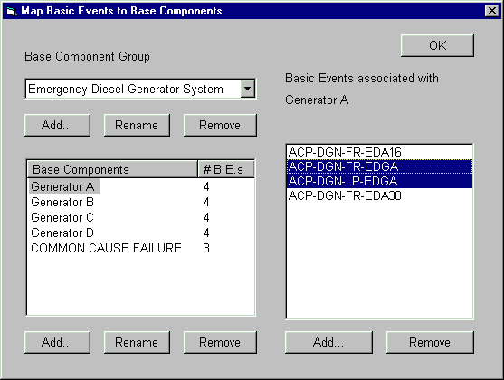

  - Creation of Component Hierarchy
The Risk Monitor program defines components as physical objects which work together to achieve system success. Risk Monitor allows components to be placed in a user defined hierarchy. First a hierarchy itself needs to be structured. By default, a hierarchy is packaged with the system that includes 5 levels. The order of this hierarchy is Function -> System -> Sub-System -> Train -> Component. Associated with each level in the hierarchy is an icon. Levels of hierarchy may be added or removed, up to 10 levels total. An icon may be set for each level in the hierarchy. Any icon used should be stored in the icons subdirectory of the program working directory. Once the hierarchy structure is in place, a logical hierarchy for components needs to take place. The benefit of placing components in a hierarchy is that it allows the selection of an entire system or just a small part of that system for maintenance or during a component out of service event. Since the total number of components in a system may be large this also makes it easier to locate a component. The hierarchy may be edited by right clicking on specific nodes.
In order for components to map to basic events, base components must be added to nodes. (See previous section for a description of base components). The right pane will display how many base components are immediate children of that particular node and how many base components are immediate children and children through other nodes.

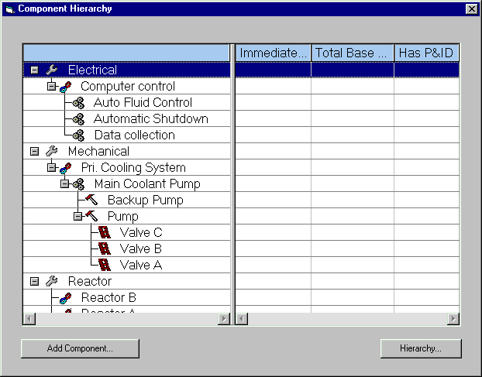

- Operational Task Management
The Operational Task Management view is the initial view the user is provided with when interacting with the Risk Monitor program. The OTM screen can be changed to list all tasks in a workspace, all out of service components in a workspace, or both. This is accomplished through the checkboxes located at the top of the tab strip. Following is an image of the OTM and a brief discussion of its parts.

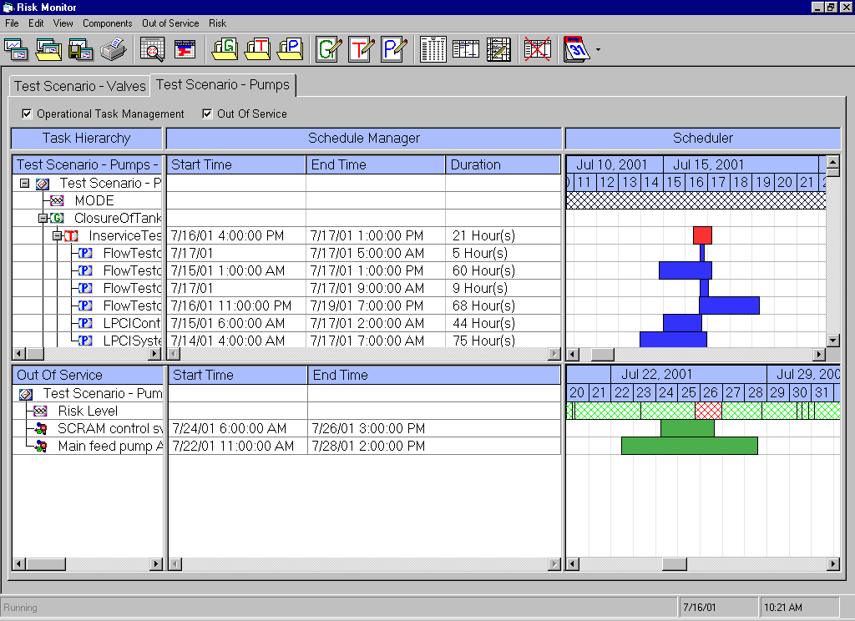
Main Tool Bar
Tab Strip
Task Tree
Out of Service List
Task Graph
Out of Service Graph

4.1 Main Tool Bar
The main tool bar contains buttons for general interaction with the program. They are as follows:

New Workspace – creates a new workspace.
Open Workspace – opens an existing workspace.
Copy Workspace – copies an existing workspace.
Print – prints a comprehensive printout of data and risk values.
Review and Oversight – displays the Review and Oversight View.
Scheduler – displays the Operational Task Management View.
Create Group – create a new group of tasks.
Create Task – create a new task consisting of procedures.
Create Procedure – create a new procedure consisting of components.
Edit Group – edit an existing group.
Edit Task – edit an existing task.
Edit Procedure – edit an exiting procedure.
Add Group – add a group of tasks to the active workspace.
Add Task – add a task to the active workspace.
Add Mode – add a mode to the active workspace.
Remove – removes a selected group of tasks, task or procedure from the active workspace.
Time – the time button allows the user to change the start and end time of the active workspace, while the associated drop down menu is used to change the scale of the Task Graph and the Out of Service Graph.

4.2 Task Tree
The Task Tree displays the tasks currently present in the active workspace. Modes, groups of tasks, and procedures are shown here along with their start and end times. Items listed in this view can be added or modified through items listed in the menus or by clicking on the appropriate area of the tree.

4.2.1 Add Group
To add a group to the active workspace click on the Add Group Button on the Main Tool Bar, select the Add Group option from the Task menu or Right click the mouse over the tree and select Add Group.

4.2.2 Add Task
To add a task to the active workspace click on the Add Task Button on the Main Tool Bar, select the Add Task option from the Task menu or Right click the mouse over the tree and select Add Task.

4.2.3 Add Mode
To add a mode to the active workspace click on the Add Mode Button on the Main Tool Bar, select the Add Mode option from the Task menu or Right click the mouse over the tree and select Add Mode.

4.3.4 Remove
Removing an element from the Task Tree requires selecting or highlighting the desired element and then clicking the Remove button located on the Main Tool Bar or right clicking on the tree and selecting the Remove option. The remove option can also be found under the Task menu.

4.2.5 Time
There are multiple was of changing the start and end times associated with tasks, procedures and modes. For tasks and procedures a double click on one of the cells listed to the right of the tree will bring up an edit window for that object. A single click highlighting a row and the selection of Change Start and End Time from the Task menu will produce the same result. Other methods will be discussed as part of the Task Graph.

4.2.6 Component List
Each procedure listed in the Task Tree, denoted by the [proc icon], has a list of components associated with it. To make access to these components easy a double left mouse click on the procedure name will produce a list of components associated with that procedure. Selecting a component from that list will produce an image of that component (this occurs only if P&IDs have been attached to components).

4.3 Task Graph
The Task Graph is a graphical representation of the information in the Task Tree. Entries can be modified through the task graph. However, items in the graph may be difficult to see dependant on the current graph scale. This scale can be changed by selecting the appropriate option from the drop down menu located with the Time button on the Main Tool Bar.

The Data portion of the Task Graph has two main parts. A mode bar located at the top of the graph and the lower display portion of the graph. The mode bar displays the modes that have previously been added to the active workspace while the lower portion displays the task and procedure data. Any element (mode, task or procedure) can be edited by clicking and dragging on the item. (The mouse cursor will change to let the user know when a drag and drop operation is possible.)

4.4 Out of Service List
The Out of Service List (OOS) is a list of components currently unavailable to the system or model. Components can be added and removed from the list by right clicking over the list its self and selecting the appropriate option or through the Components menu. Much like the Task Tree, clicking on the cells to the left of the list can modify the Out of Service times. If P&IDs have been included in the SAPHIRE model double clicking on the name of a component listed will provide an image of that component.

If the OOS is not visible check the Out of Service check box at the top of the tab strip.

4.5 Out of Service Graph
The out of service graph graphically displays the information in the OOS. The data contained here can be changed through drag and drop operations like those of the Task Graph.

4.6 Modes and Risk Levels
At the top of each graph, Task Graph and Out of Service Graph, there is a stationary bar. This bar represents either the current mode or risk level respectively. Modes are added by the user and correspond to databases belonging to SAPHIRE. An example mode would be startup, shutdown, or perhaps cooling. The Risk Monitor program checks to make sure that there are no conflicts between modes and the OOS. (Certain components can not become disabled during specific modes.)

The risk bar provides a high (red), medium (yellow) and low (green) risk assessment to the user. While more precise data can be determined from the Review and Oversight view this provides a simple overall assessment and allows for the quick pinpointing of trouble spots.

- Review and Oversight
The Review and Oversight (RO) view provides a detailed analysis of the risk level of a system at a given point in time. There are two main aspects to the RO. The first is a calendar view (shown below). The second is a risk graph showing risk over a finite period of time (also shown below).

The calendar view, much like the Out of Service Graph, provides a general outlook by letting the user know the day’s average values. To obtain the more detailed graph view from the calendar view double click on the day in question.

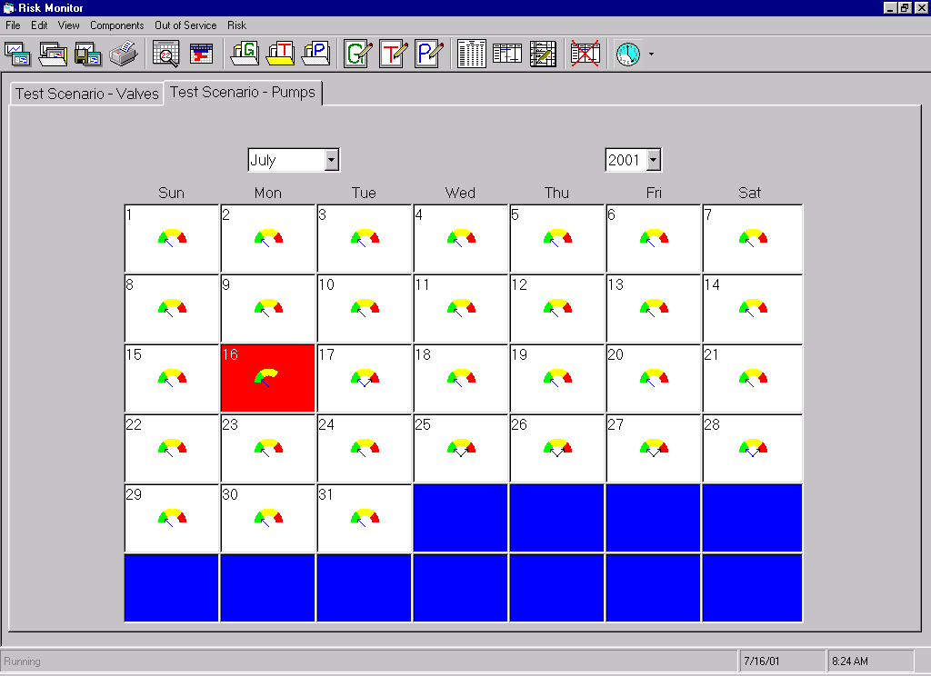
Calendar View
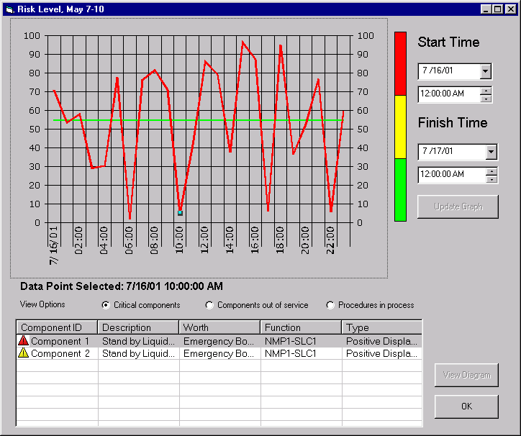
Risk Graph

The Risk Graph is able to display risk level over a specified period of time. Although by default the day that was selected on the calendar is used as the start and end time, these dates may be changed easily and risk recalculated by pressing Update Graph.
For any point on the risk graph Risk Monitor is able to return a list of critical components, a list of the components currently out of service or a list of all the procedures currently in progress.

The Critical Component option is a list of those components, which if failed at that point would increase risk level the most.

The Components Out of Service list shows those components out of service due to maintenance or out of service events at that point. Each type of component out of service is represented by either the maintenance or out of service icon.

The Procedures in Process list shows those procedures that are scheduled in the task management view at that point in time.

